Final Project Report

1. Introduction
1.1 Project Overview
The Plant Growth Analysis project focuses on understanding how various environmental and agricultural factors influence plant growth outcomes. Using a structured dataset and Power BI as the primary analytics tool, the project analyzes parameters such as soil type, water frequency, fertilizer type, temperature, humidity, and sunlight hours. The objective is to derive meaningful insights through data visualization that support informed decision-making in agriculture and plant management practices.

1.2 Objectives
- To analyze plant growth patterns using environmental and agricultural data
- To identify key factors affecting plant growth milestones
- To perform data cleaning and preprocessing using Power Query
- To develop meaningful visualizations using Power BI
- To design an interactive dashboard for effective data interpretation

2. Project Initialization and Planning Phase
2.1 Define Problem Statement
Farmers and agricultural analysts often struggle to determine which environmental conditions and farming practices most effectively support plant growth. The lack of data-driven insights leads to inefficient resource utilization, inconsistent crop growth, and reduced productivity. This project aims to address this problem by analyzing plant growth data and identifying patterns that link growth milestones with soil, water, temperature, humidity, and sunlight conditions.

2.2 Project Proposal (Proposed Solution)
The proposed solution involves collecting plant growth data and analyzing it using Power BI. The project applies data preprocessing techniques, DAX calculations, and interactive visualizations to evaluate the impact of environmental factors on plant growth milestones. The outcome is a dynamic dashboard that helps stakeholders understand growth trends and optimize agricultural decisions.

2.3 Initial Project Planning
The project was planned in phases, starting with data collection, followed by preprocessing, analysis, visualization development, dashboard creation, and final reporting. Tasks were organized into sprints to ensure timely completion and systematic progress tracking.

3. Data Collection and Preprocessing Phase
3.1 Data Collection Plan and Raw Data Sources Identified
The dataset used in this project was sourced from an open-source agricultural data repository. It contains structured information related to plant growth conditions, including soil type, water frequency, fertilizer type, temperature, humidity, sunlight hours, and growth milestone indicators. The data was collected in CSV format and imported into Power BI.

3.2 Data Quality Report
Several data quality issues were identified, such as missing values, inconsistent category labels, and incorrect data types. Missing values were handled using appropriate replacement techniques, categorical inconsistencies were standardized, and data types were corrected using Power Query to ensure reliable analysis.

3.3 Data Exploration and Preprocessing
Initial data exploration was performed to understand the dataset structure and distributions. Power Query was used for:
- Removing duplicates
- Handling missing values
- Creating derived columns (descriptions for temperature and humidity ranges)
- Converting data types
- Filtering and sorting records
The cleaned dataset was then loaded into Power BI for modeling and visualization.

4. Data Visualization
4.1 Framing Business Questions
Business questions were framed to guide visualization development, such as:
- How does soil type affect plant growth milestones?
- Which water frequency results in higher growth milestone percentages?
- How do temperature and humidity levels influence plant growth?
These questions helped define relevant KPIs and metrics.

4.2 Developing Visualizations
Appropriate visuals such as bar charts, column charts, line charts, and cards were developed in Power BI. These visualizations represent growth milestone counts, percentages, and average environmental conditions, making complex data easy to interpret.

5. Dashboard
5.1 Dashboard Design File
An interactive Power BI dashboard was created to consolidate all key visualizations. The dashboard includes filters for soil type, water frequency, fertilizer type, and environmental conditions, allowing users to explore the data dynamically and gain actionable insights.

6. Report
6.1 Story Design File
The report presents a narrative flow of insights derived from the dashboard. Each visualization is explained with supporting observations, enabling stakeholders to understand relationships between environmental factors and plant growth outcomes.

7. Performance Testing
7.1 Utilization of Data Filters
Multiple slicers and filters were implemented to enhance interactivity and performance. Users can filter data by soil type, humidity level, temperature description, and water frequency.

7.2 Number of Calculation Fields
Several DAX measures were created, including:
- Growth Milestone Count
- Growth Milestone Percentage
- Average Temperature
- Average Humidity
- Average Sunlight Hours

7.3 Number of Visualizations
The project includes more than eight visualizations, covering all key metrics and business questions required for comprehensive analysis.

8. Conclusion / Observation
The analysis reveals that plant growth milestones are significantly influenced by soil type, water frequency, and environmental conditions. Certain combinations of soil and watering schedules consistently show higher growth success rates. The dashboard provides a clear and effective way to monitor and evaluate these factors.

9. Future Scope
- Integration of real-time IoT sensor data for live monitoring
- Predictive modeling to forecast plant growth outcomes
- Expansion of dataset to include crop yield and disease factors
- Deployment of the dashboard as a web-based analytics tool

10. Appendix
10.1 Source Code (if any)
DAX measures and Power Query transformation steps used in the project are included within the Power BI report file.

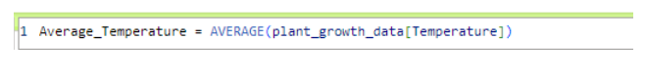
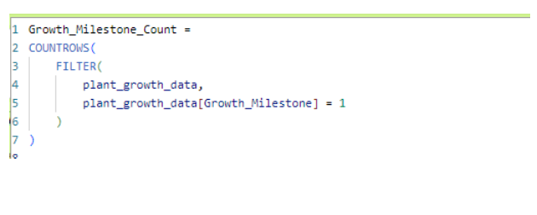
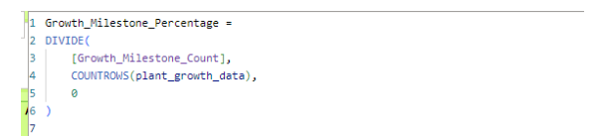
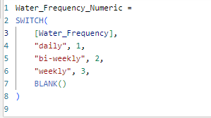
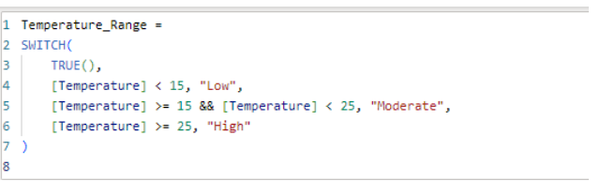
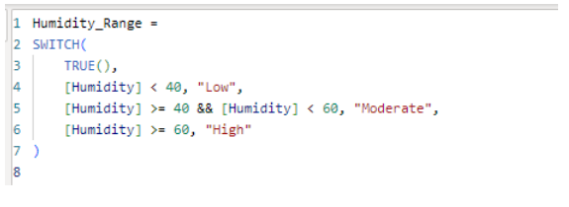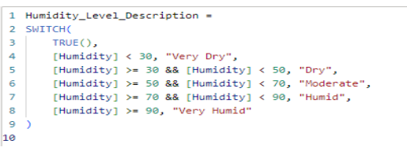

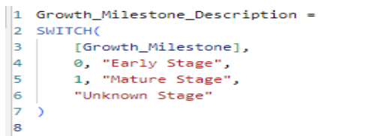

10.2 GitHub & Project Demo Link
- GitHub Repository: (To be added)
- Project Demo Video: (To be added)

